**Chapter 1 - Digestive System**

**All Lectures Uploaded on YouTube:**

[**https://tinyurl.com/fkm10-biology**](https://tinyurl.com/fkm10-biology)

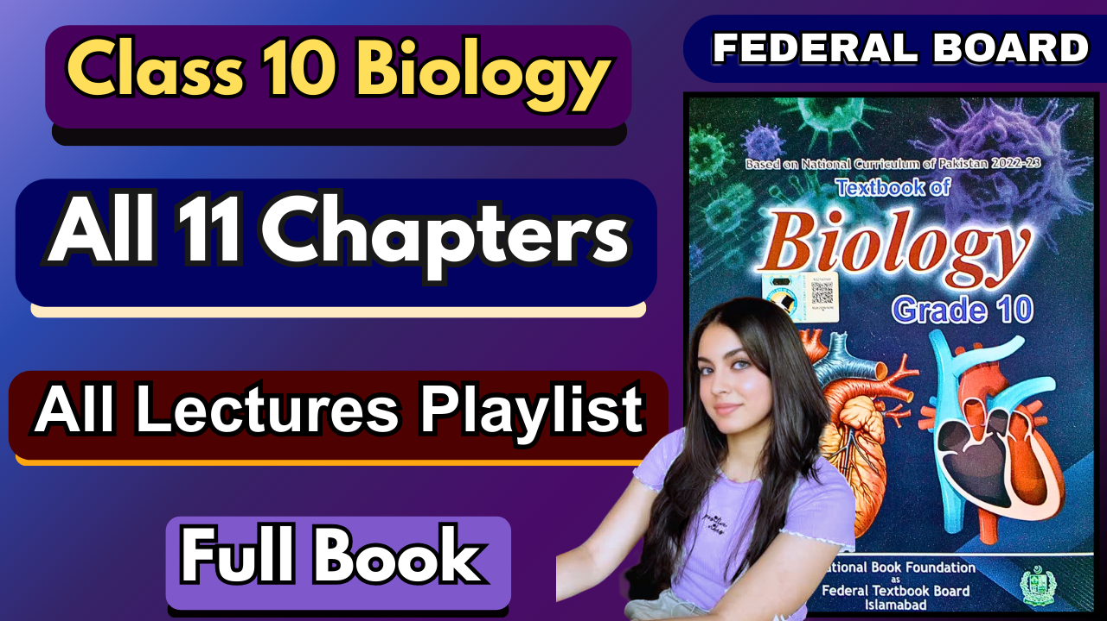

**MCQ’S**

1. B
2. C
3. A
4. C
5. A
6. D
7. A
8. B
9. A
10. A
11. A
12. D
13. B
14. B

**Short Answer Questions**

1. **Saliva**: moistens the food and contains enzymes like amylase, which start the chemical digestion of the food

**Gall bladder**: stores the bile, which is formed in the liver ,and releases it into the small intestine for the emulsification of fats

**Pancreas**: a gland which contains digestive enzymes (amylase, protease, lipase) and releases them into the small intestine for digestion through the pancreatic duct

**Villus**: a finger-like projection which increases the surface area for the absorption of digested food

**Bile**: a fluid that emulsifies the fat molecules into small fat droplets for efficient digestion of fats

**Gastric gland:** contains hydrochloric acid, renin, pepsinogen, and mucus in the stomach

**Renin**: an enzyme found in infants for the digestion of milk protein

**HCl in the stomach**: kills germs or any pathogens entering the stomach, provides acidic pH for pepsin to work in

**Hepatic portal vein**: transports absorbed nutrients from the intestines to the liver

1. 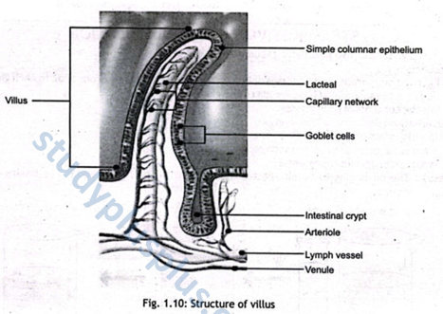
2. Salivary glands: amylase for starch digestion

Gastric glands, pepsin, and renin for protein digestion

Pancreas: amylase, trypsinogen, and lipase for starch, protein, and fats

Crypts are in the small intestine for the complete digestion of nutrients

1. Pepsin is formed in an inactive form (pepsinogen) to prevent it from digesting the stomach walls. If pepsin were directly released in the stomach, it would have started digesting the helpful tissues that produce the stomach wall
2. Nutrients are distributed through the bloodstream and absorbed by the intestinal wall. They are transported to cells in the body where they are used for growth, production of new cells, and repair of wounds and internal damage.
3. Chewing is the main part of mechanical digestion, which helps increase the food's surface area for chemical digestion to be more efficient and for enzymes to easily work on it. It also forms a bolus form of food for it to be easily swallowed and passed on by the oesophagus
4. Pancreatic juice contains vital enzymes; if it did not reach the small intestine, the digestion of fats, proteins, and starch would not have been completed, or severely impacted. This could lead to nutrient deficiencies, indigestion, and weakened health. Overall, growth and repair would have been impaired
5. Pepsin is in the stomach where the pH is quite low due to acidic medium (HCl), making acidic regions its optimum pH to work in, whereas in the small intestine the pH is high and towards an alkaline side, making pepsin unable to perform its functions
6. Bile is released into the duodenum, which is the first part of the small intestine, where it emulsifies fats. It is therefore not found in the large intestine or the stomach
7. The stomach wall needs protection against its own HCl, which is a strong acid and, without mucus, would be dangerous for the stomach lining, causing ulcers or digestive problems. Secondly, without mucus, pepsin would have acted on the stomach wall, digesting it.
8. Protease: substrate– proteins and product– amino acids

Amylase: substrate– starch, product– maltose or glucose

Lipase: substrate– fats and product– fatty acids and glycerol

1. Incisors: to cut and bite the food

Canines: to tear and pierce the food

Pre-molars and Molars: to crush and grind the food

1. Mechanical digestion involves physical processes like chewing, crushing, and churning of the food that break down the food into **smaller pieces**. (other than oral cavity: the churning of food in the stomach due to movement)

Chemical digestion involves enzymes breaking down the food into simpler molecules. (Oral cavity: salivary glands release amylase to break down starch molecules.)

**Extensive Answer Questions:**

1. The **alimentary canal** is a continuous muscular tube that extends from the mouth to the anus. It is divided into several main regions, each with specialised functions in **digestion and absorption**. The **mouth** is the entry point where mechanical digestion through chewing and chemical digestion through saliva begins. From there, food passes through the **pharynx**, a common passageway for food and air, into the **oesophagus**, a muscular tube that moves food to the stomach via peristalsis. The **stomach** is a muscular, sac-like organ where food is mixed with gastric juices, initiating protein digestion. The **small intestine** is the major site for enzymatic digestion and nutrient absorption, consisting of the duodenum, jejunum, and ileum. Finally, the **large intestine** absorbs water and forms faeces. It includes the caecum, colon, rectum, and ends at the **anus**, where waste is expelled.
2. Several accessory organs support the digestive functions of the alimentary canal. The **salivary glands** (parotid, submandibular, sublingual) secrete saliva, which contains enzymes like amylase that begin starch digestion. The **liver**, the largest internal organ, produces bile, which emulsifies fats. Bile is stored and concentrated in the **gallbladder** and released into the small intestine. The **pancreas** secretes digestive enzymes such as lipase, proteases, and amylase into the duodenum through the pancreatic duct. These enzymes aid in breaking down all major food groups. Additionally, the pancreas produces bicarbonate ions that neutralise stomach acid in the small intestine.
3. **Swallowing** is the process that moves food from the mouth to the stomach and involves four phases. In the **oral preparatory phase**, the tongue pushes the food (*bolus*) backwards against the hard palate. During the **oral transport phase,** the soft palate closes the nasal cavity to prevent food from entering it. The **pharyngeal phase** is where swallowing becomes involuntary; the larynx rises, and the epiglottis covers the glottis to prevent food from entering the windpipe. Finally, in the **oesophageal phase**, the bolus is pushed down the oesophagus to the stomach by rhythmic muscle contractions called peristalsis.
4. **Peristalsis** is the wave-like muscle contraction that moves food along the digestive tract. It starts in the oesophagus and continues through the intestines. The walls of the alimentary canal have two muscle layers: circular and longitudinal. When the **circular muscles** behind the food bolus contract and the **longitudinal muscles** ahead of it relax, the lumen narrows and shortens, pushing the bolus forward. This alternating contraction and relaxation of muscles ensures the smooth movement of food.

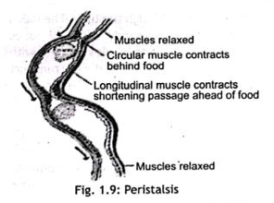

1. In the **stomach**, both mechanical and chemical digestion occur. The muscular walls churn the ingested food, mixing it with gastric juice to form a semi-liquid mixture called **chyme**. The gastric glands in the stomach lining secrete hydrochloric acid (HCl), pepsinogen, and mucus. HCl activates pepsinogen to form pepsin, an enzyme that digests proteins into peptides. The acidic environment also helps kill harmful microbes. Mucus lines the stomach wall to protect it from acidic damage. The food stays in the stomach for about 2–3 hours before slowly being released into the small intestine for further digestion.
2. The **small intestine** is the principal site for digestion and nutrient absorption. In the **duodenum**, digestive enzymes from the pancreas (amylase, lipase, trypsin) and bile from the liver/gallbladder are secreted. Bile breaks down fats into smaller droplets (**emulsification**), and pancreatic enzymes further digest carbohydrates, proteins, and lipids. The intestinal glands also secrete enzymes like maltase, peptidase, and sucrase. In the jejunum and ileum, absorption of nutrients occurs through the villi and microvilli, which greatly increase the surface area. Glucose, amino acids, vitamins, and minerals enter blood capillaries, while fatty acids and glycerol enter lymph vessels.
3. A **villus (plural: villi)** is a finger-like projection lining the small intestine that **increases the surface area for absorption**. Each villus contains a capillary network and a lacteal (lymph vessel). The epithelial cells on its surface have microvilli, forming a brush border to further enhance absorption. Capillaries absorb glucose, amino acids, water-soluble vitamins, and minerals, while the lacteal absorbs fatty acids and glycerol. Goblet cells present in the villi secrete mucus to lubricate the intestinal lining.
4. The liver performs multiple vital functions. In digestion, it **produces bile,** which emulsifies fats, making them easier to digest by lipase. The liver also regulates blood glucose levels by storing excess glucose as glycogen (glycogenesis) and releasing it when needed (glycogenolysis). It **detoxifies harmful substances**, synthesises blood proteins (like albumin and clotting factors), and stores vitamins (A, D, B12) and iron. It converts ammonia into urea (deamination) for excretion and breaks down old red blood cells. Overall, the liver is central to metabolism, detoxification, and digestion.

#### a. Diarrhea

* **Symptoms:** Watery, frequent stools, abdominal cramps, dehydration, fatigue.
* **Causes:** Bacterial or viral infections (e.g., E. coli, rotavirus), contaminated food/water, food intolerance.
* **Treatment:** Oral rehydration therapy (ORS), zinc supplements, antibiotics (if bacterial), rest.
* **Prevention:** Drink clean water, wash hands regularly, ensure food hygiene, and vaccinations.

#### **B. Constipation**

* **Symptoms:** Difficulty in passing stool, hard and dry stools, abdominal bloating.
* **Causes:** Low fibre diet, lack of physical activity, dehydration, and ignoring the urge to defecate.
* **Treatment:** High-fibre diet, increased fluid intake, exercise, laxatives if necessary.
* **Prevention:** Eat fruits, vegetables, drink water, avoid processed foods, and maintain regular bowel habits.

#### **C. Ulcer**

* **Symptoms:** Burning stomach pain, bloating, nausea, vomiting, weight loss.
* **Causes:** Helicobacter pylori infection, smoking, and stress.
* **Treatment:** Antibiotics (for H. pylori), antacids, proton pump inhibitors, and avoiding spicy food.
* **Prevention:** Avoid long-term NSAID use, quit smoking, manage stress, eat balanced meals.

